NRI TEMPLATE – USER INSTRUCTIONS
- Using This Template
This template is intended to support municipalities in preparing a Natural Resources Inventory (NRI) using data available through the CDRPC NRI Mapping Tool.
All sections of this template are designed to be flexible and should be adapted to reflect local conditions, priorities, and available data.
Text highlighted in red throughout the document indicates content that must be reviewed and adjusted by each municipality. This may include inserting local data, adjusting descriptions, or removing sections that are not applicable.
Municipalities are encouraged to:
- Adapt content to reflect local conditions
- Add additional sections or data where relevant
- Adjust formatting and layout as needed
- Incorporate local knowledge and planning priorities
The final document should reflect the specific characteristics and goals of each municipality.
- Working with Maps
Maps used in this template are available through the CDRPC NRI Mapping Tool:
https://experience.arcgis.com/experience/5cd12060e1484940bb7238e9bcdd4adc/page/NRI-Home
After selecting and downloading maps for your municipality, each municipality is responsible for preparing the files for insertion into the template.
Maps can be downloaded as either JPEG (.jpg) or PDF files:
- JPEG files can be inserted directly into the template (instructions below).
- PDF files can be added as full-page maps using Adobe Acrobat or similar software.
Inserting JPEG Maps into the Template
Step 1 – Download the image as a JPEG (.jpg) from the mapping tool
Step 2 – Insert map into the template
- Pre-defined areas have been included in the template to indicate where maps should be placed (in blue). Select the blue placeholder area
- Click the image icon
- Choose “Insert picture from file”
- Select the corresponding JPEG image
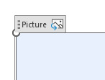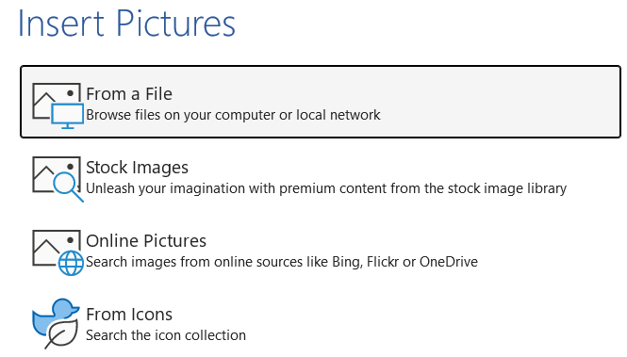
These placeholders are provided as guides. Municipalities may adjust the size, placement, or formatting of maps as needed to improve readability or layout.

- - -

‘All Category’ section: communities have complete control over bringing in different layers of interest to make their own map based on local need.
- There are other layers available in the All Category tab that are not included in the pre-made maps.
- Not all features for each pre-made map are found in all communities

All Categories | Capital Region Natural Resource Inventory (NRI) - V2

