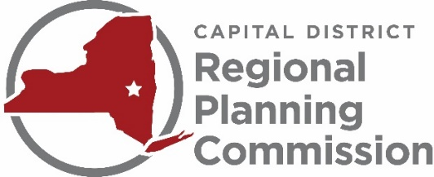

CAPITAL DISTRICT REGIONAL PLANNING COMMISSION
INTERNSHIP OPPORTUNITY

The Capital District Regional Planning Commission (CDRPC) is a regional planning and resource center serving Albany, Rensselaer, Saratoga, and Schenectady counties. CDRPC supports planning, sustainability, economic development, water-quality, and human services programs that have inter-municipal or regional impact. CDRPC provides objective analysis of data, trends, opportunities, and challenges relevant to the Region's economic development and planning communities. CDRPC serves the best interests of the public and private sectors by promoting intergovernmental cooperation; communicating, collaborating, and facilitating regional initiatives; and sharing information and fostering dialogue on solutions to regional problems.

More information about CDRPC is available at www.cdrpc.org.

SCOPE OF WORK:

CDRPC seeks an energetic and enthusiastic Clean Energy Intern who will work with the sustainability program staff on a variety of tasks, including program research, marketing and communication, metrics calculations, and program implementation. The successful applicant will work under the direction of the Director of Sustainability and the program outreach staff to carry out technical support tasks related to the New York State Energy Research and Development Authority’s (NYSERDA) Clean Heating and Cooling and Clean Energy Communities programs.
Specifically the duties will include:
- Conducting customer lead follow up
- Providing educational information about heat pumps and energy efficiency
- Assisting the clean heating and cooling campaign by supporting municipal micro-campaigns
- Developing and implementing social media, eblasts, and on-the-ground marketing strategies
- Maintaining Airtable database and developing program metrics
- Data collection and analysis for benchmarking municipal building energy use
- Assisting communities with EV rebate reporting
- Assisting local governments to become Clean Energy Communities Designated and Climate Smart Communities Certified
- Providing support for community workshops and webinars
- Develop graphics and other means of communicating program initiatives and accomplishments
Preferred Qualifications
- General knowledge regarding local, state, and federal renewable energy and energy efficiency policies
- Proficiency in Microsoft Office Applications, Adobe Suite, and Wordpress. Optional but encouraged experience with Zoom, Mailchimp and AirTable.
- Excellent writing, verbal, and presentation skills
- Experience with social media platforms including Facebook, Twitter, and LinkedIn
- Ability to work in a fast-paced environment on complex projects with multiple deadlines
- Enrolled in an accredited Master’s or undergraduate degree program in environmental studies, energy, planning, public administration or a related field.
Compensation:
$17 per hour

Hours:
15-18 hours per week, flexible schedule. Internship is initially for December 2020 through August 2021, with potential continuation through the remainder of 2021.

To Apply:
Please submit a resume and cover letter by Friday, November 23, 2020 to todd@cdrpc.org.

CDRPC is an Equal Opportunity Employer

