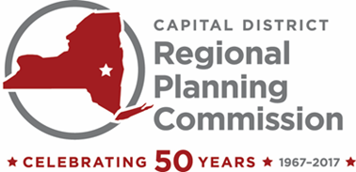 | One Park Place, Suite 102 | Albany, New York 12205  (518) 453-0850 | (518) 453-0856, fax | www.cdrpc.org

2017 Officers

Chair
Judith Breselor, AICP

Vice Chair
Jason Kemper

Secretary
Gary Hughes

Treasurer
Kristin Swinton

Executive Director
Mark A. Castiglione, AICP

Members

Albany County
G. Michael Apostol
Willard A. Bruce
Lucille M. McKnight
Michael Morelli
Kristin Swinton

Rensselaer County
Judy H. Breselor
Stan Brownell
James D. Shaughnessy
Michael Stammel
Jacqueline Stellone

Saratoga County
Fred Acunto
Philip Barrett
Jason Kemper
John Murray
Paul Sausville

Schenectady County
B. Donald Ackerman
Nancy Casso
Gary Hughes
Joe Landry
Barbara Mauro

COMMISSION MEETING

8:30 am, Wednesday, May 17, 2017
CDRPC Office
One Park Place
Albany, New York
Call In Number: 712-432-1500
Access Code: 141631#

AGENDA

- March 15, 2017 Meeting Notes; January 18, 2017 Meeting Minutes*

- Financial Statement through April 30th, 2017 (Memo 17-11)*

- CEDS Strategy Committee, Sean Maguire

- Clean Energy Communities and Climate Smart Communities Program Update (Memo 17-12)

- Proposed Revised 2017 Budget (Memo 17-13)*

- 50th Anniversary Committee

- Audit Update/ Bylaws Update (Memo- 17-14)

- Adopt Records Retention General Schedule MI-1, Resolution 1 of 2017 (Memo 17-15)*

- Presentation: NYSERDA Clean Energy Community Program: Todd Fabozzi and Robyn Reynolds.

- LTCP CSO Memo (Memo 17-16)

- Staff Activity Report

- Other Business

- Next Commission Meeting Date: July 19th, at 10:00am

*Formal Board Action Anticipated

