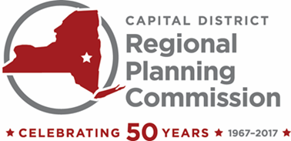 | One Park Place, Suite 102 | Albany, New York 12205  (518) 453-0850 | (518) 453-0856, fax | www.cdrpc.org

2017 Officers

Chair
Judith Breselor, AICP

Vice Chair
Jason Kemper

Secretary
Gary Hughes

Treasurer
Kristin Swinton

Executive Director
Mark A. Castiglione, AICP

Members

Albany County
G. Michael Apostol
Willard A. Bruce
Lucille M. McKnight
Michael Morelli
Kristin Swinton

Rensselaer County
Judy H. Breselor
Stan Brownell
James D. Shaughnessy
Michael Stammel
Jacqueline Stellone

Saratoga County
Philip Barrett
Jason Kemper
John Murray
Paul Sausville
Vacant

Schenectady County
B. Donald Ackerman
Nancy Casso
Gary Hughes
Joe Landry
Barbara Mauro

COMMISSION MEETING

10 am, Wednesday, July 19, 2017
Albany County Sewer District North Plant
1 Canal Rd S, Albany, NY 12204

AGENDA

- Welcome and Introductions

- May 17th 2017 Meeting Minutes*

- Financial Statement through June 30th, 2017 (Memo 17-17)*

- 2016 Audit Presentation (Memo 17-18)

- 2018 Proposed Preliminary Budget (Memo 17-19)*

- Bylaws Update (Memo 17-20)

- 50th Anniversary Event (Memo 17-21)

- LTCP CSO Memo (Memo 17-22)

- Staff Activity Report

- Other Business

- Presentation: Water Quality/ Waste to Energy: The Development of a Regional Bio-solids Anaerobic Digester by Timothy Murphy, Executive Director of the Albany County Sewer District and Dan Rourke, PE, Executive Director of the Saratoga County Sewer District #1.

- Next Scheduled Commission Meeting Date: October 18, 2017 at 4:30pm

*Formal Board Action Anticipated

