Capital District Community GHG Inventory
Executive Summary Template Introduction
A community greenhouse gas (GHG) emissions inventory accounts for the sum total of all heat-trapping GHGs released into the atmosphere as the result of emission causing activities occurring within a community boundary. This Executive Summary Template offers a quick and interesting format to provide snapshot of the sources of emissions from community activities and to promote awareness of your community baseline from which future emissions reductions and progress can be measured.
What is included in a Community GHG Inventory?
The Capital District 2010 Regional GHG Inventory calculated community-wide GHG emissions by sector, including residential, commercial, industrial, transportation, solid waste, industrial processes, and agriculture, for a 2010 baseline year (see Sector Descriptions below).
This template automatically pulls GHG inventory data for all 160 municipalities in the Capital District as provided in Table B.1 of the Capital District 2010 Regional GHG Inventory report.
SECTOR | SOURCE DESCRIPTIONS
Residential | Stationary energy used in residential, commercial, industrial buildings and other non-mobile uses (e.g., electricity, natural gas, fuel oils, wood and propane).
Commercial
Industrial
Processes | Non-energy process emissions from industrial activity & fugitive emissions from fuel systems (e.g., C0₂ from cement production, A/C coolants, & leakages).
Transportation | Fuel consumption for on-road transportation, passenger & freight rail, aviation, marine transit & off-road vehicles.
Waste | Non-energy process emissions from landfills & wastewater treatment plants or septic systems. (e.g., methane emissions from anaerobic decay).
Agriculture | Non-energy emissions from crops & livestock (e.g., methane & nitrous oxide emissions from fertilizers).
Why and how should I communicate the results of the Community GHG Inventory?
Conducting a community-wide GHG inventory is one of the first steps of the Climate Smart Communities (CSC) program under Pledge Element 2: Set Goals, Inventory Emissions, Plan for Climate Action. This Template helps local governments to also address Pledge Element 9: Inform and Inspire the Public. The community GHG inventory reveals which sectors have the highest emission levels to help local government create and implement policies, projects, and programs that incentivize and encourage GHG reductions in those specific sectors throughout the community.
It is important to communicate GHG emissions in an easy-to-digest way that will motivate community members to take action. This one-page Executive Summary Template is designed to help you achieve this goal by featuring simple language and clear graphics that help the public visualize and comprehend the meaning of the results. Once completed, the Executive Summary can be posted online, provided to local officials, and/or distributed at community events.
To start using the template, enter the [Local Government Name]” in the text field below (i.e., City of Watervliet, Village of Dobbs Ferry, etc.). This will automatically update all in-text references to your community’s name in the Executive Summary Template.
ENTER THE: [Local Government Name]
Instructions for updating the table, charts, and visualizations are provided in comment boxes on the Executive Summary page and on Update the GHG Equivalency Chart page that follows. Let’s get started!
[Local Government Name]
Community GHG Inventory Executive Summary
The [Local Government Name]’s community greenhouse gas (GHG) inventory identifies and quantifies the sources of GHG emissions from community activities and establishes a baseline from which future emissions reductions and progress can be measured. New York State conducted regional GHG emissions inventories for the baseline year 2010, which included emissions for each community in the Capital District. Table 1 lists the [Local Government Name]’s emission sectors and Figure 1 shows GHG emissions associated with each sector. [GHG Emission Sector] is [Local Government Name]’s largest source of GHG emissions, comprising approximately [%] percent of 2010 community emissions. _ _ _ _ __ _ _ _ __ _ _ _ __ _ _ _ __ _ _ _ __ _ _ _ __ _ _ _ __ _ _ _ __ _ _ _ __ _ _ _ __ _ _ _ __ _ _ _ __ _ _ _ ___ _ _ _ __ _ _ _ __ _ _ _ __ _ _ _ __ _ _ _ __ _ _ _ __ _ _ _ __ _ _ _ __ _ _ _ __ _ _ ___ _ _ _ __ _ _ _ __ _ _ _ __ _ _ _ __ _ _ _ __ _ _ _ __ _ _ _ __ _ _ _ __ _ _ _ __ _ _ ___ _ _ _ __ _ _ _ __
Data Source: Capital District 2010 Regional GHG Inventory, NYSERDA (pages 54-58), accessible at http://www.cdrpc.org/CSCommunities/Capital_District_Regional_GHG_Inventory_Final.pdf
2010 TOTAL COMMUNITY GHG EMISSION
OF [ENTER TOTAL EMISSIONS] MTCDE
IS EQUIVALENT TO CO₂ EMISSIONS FROM
[Enter miles] |  | [Enter tons]

HOW DO PER CAPITA EMISSIONS COMPARE TO COUNTY AND REGIONAL AVERAGES?

INSTRUCTIONS: Update the GHG Equivalencies Chart
The Environmental Protection Agency (EPA) Greenhouse Gas Equivalencies Calculator can help translate community GHG emission and/or reductions into every day terms that better resonate with community members. The GHG equivalency chart on the right hand column of the Executive Summary Template uses this tool to help convey the GHG emission information of your community in an easy-to-understand way to your audiences.

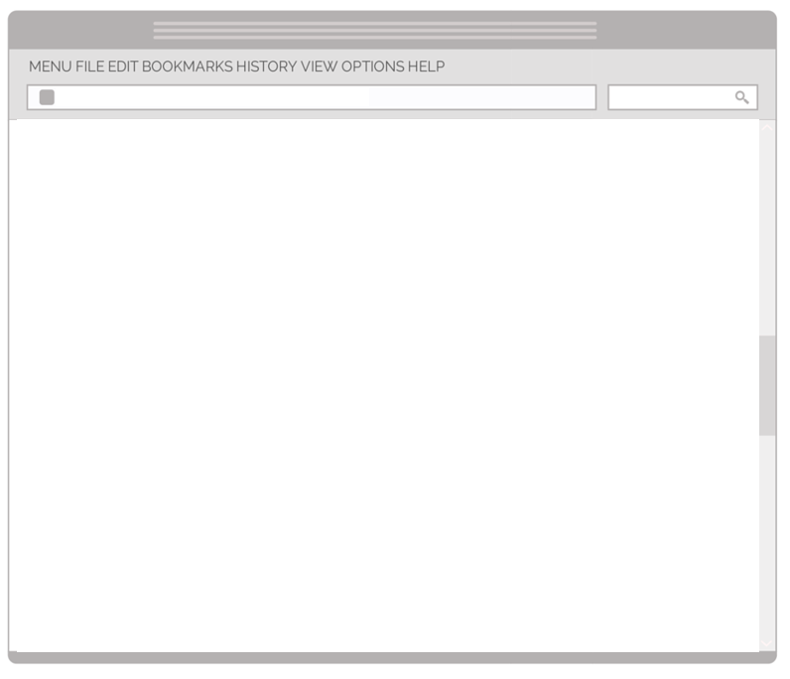
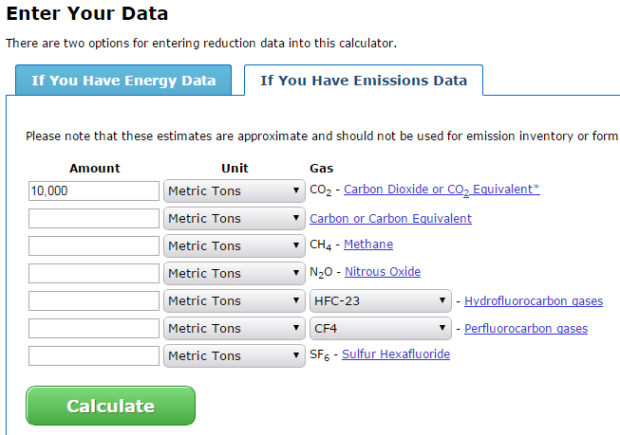
Step 1: Click and update the [ENTER TOTAL EMISSIONS] field here with the Total Emissions of your community, as identified in Table 1.
http://www.epa.gov/cleanenergy/energy-resources/calculator.html
Step 2: Go to the EPA Greenhouse Gas Equivalencies Calculator website at http://www.epa.gov/cleanenergy/energy-resources/calculator.html. Under “Enter Your Data”, choose the “If You Have Emission Data” tab and enter your community’s Total Emissions in the first row “Amount” for CO₂. Make sure “Unit” is set for “Metric Tons”. Click “Calculate” to get Equivalency Results. See screenshot on the right for more detail.
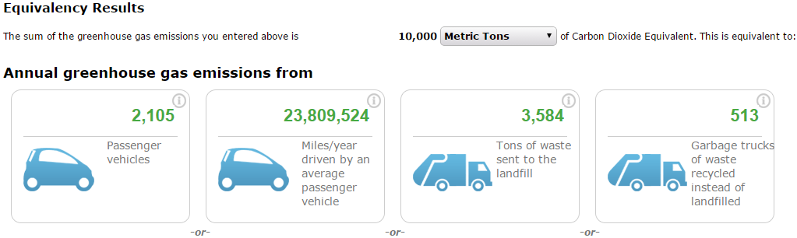
Step 3: Under “Equivalency Results”, find the “Annual greenhouse gas emissions” equivalent numbers for “Miles/year driven by an average passenger vehicle” and “Tons of waste sent to the landfill”. Enter these two results respectively in the [Enter miles] and [Enter tons] fields here to complete the GHG equivalency chart. See screenshot below for more detail.

