Climate Action Plan Template

Local Actions for Reducing Greenhouse Gas Emissions

Local
Government Seal

Approved by [Local Authority]
[Date Approved]
[Reference to Public Record] [Reference to Further Information]
Produced by [Name of Lead Department or Task Force]
INTRODUCTION
How to Use the CAP Template [DELETE PAGE WHEN FINISHED]

Completing a Climate Action Plan (CAP) is an important part of the Climate Smart Communities (CSC) program under Pledge Element 2: Set Goals, Inventory Emissions, Plan for Climate Action. A climate action plan is a strategic document that outlines a collection of initiatives and policies that reduce greenhouse gas (GHG) emissions. Using a GHG emissions inventory as the foundation, a climate action plan defines GHG reduction goals based on local priorities and provides the guiding framework for achieving those goals.
The CSC Climate Action Plan Template (CAP Template) accompanies the CSC Climate Action Planning Guide that was developed to assist local governments in developing a strategic plan for reducing GHG emissions. The CAP Template is designed to expedite the development of a custom climate action plan document by reducing the time needed to create and publish content and to encourage local governments to implement actions that would help them become certified under the CSC Certification Program. The CSC Certification Program is a rating system that awards points to actions that reduce greenhouse gas emissions, enhance local resiliency, or supports green economic development. We hope that this template and the embedded tools help your local government plan for climate protection and move forward with implementation.
HOW THIS TEMPLATE IS ORGANIZED
The CAP Template follows the CAP outline recommended in the CSC Climate Action Planning Guide. The structure enables local governments to input information about planning processes, goal development and greenhouse gas emissions inventory data. The template categorizes actions from the CSC Certification Program into example focus areas, including Transportation, Built Environment, and Waste & Recycling. Additional space is provided for optional focus areas.
This template was created in a Word document using the “Review” option in the toolbar to show “All Markup”, which allows users to view instructions in a comment box in the right margin. The gray line on the right-hand side of the page delineates the true edge of the page, so avoid extending pictures or other objects to the right of the grey line. Once a climate action plan is complete, the comment boxes can be deleted, which will remove the extended margin and preserve the formatting to the left of the gray line.
This document uses formatting techniques, such as page and section breaks, columns, page footers, table of contents, footnotes, Smart Art graphics, and other features. An example of a Smart Art graphic is provided to the right and used throughout the template. Click on the Smart Art graphic and notice the arrow on the left-hand side that points to the outline. Make changes to the text or layout of the Smart Art graphic in this outline by entering or deleting bulleted points. Please note that text within the graphics must be manually entered. To learn more about how these functions work, please reference the “Help” or “?” function in the top right corner of Microsoft Word. Users can enter a keyword to find out more information about how to use any of the formatting options used in this template.

GETTING STARTED
The CAP Template provides a structure for local governments to customize information to reflect local climate action planning efforts. Template users should start by reviewing the Table of Contents for an overview of the sections included in the template. Then start reading through the instructions and narrative text in each section. Local governments are encouraged to use any of the narrative text and to customize the language to reflect local circumstances.
The CSC Climate Action Plan Template (CAP Template) accompanies the CSC Climate Action Planning Guide that was developed through the CSC Regional Coordinator Pilot Program to assist local governments in developing a strategic plan for reducing GHG emissions. CAP Guide will lead you through the planning process and provide more detailed guidance for the sections included in this template.
Throughout the template you will see areas highlighted in [YELLOW BRACKETS], which indicate that specific information needs to be entered for your community. To automatically update text references throughout the template, enter your community’s information in the highlighted area below. After the CAP is complete, users should delete the instructional pages and comments throughout the template.

Enter the name of your local government here: [NAME OF LOCAL GOVERNMENT]
Enter the target year here: [TARGET YYYY]
EXCEL TOOLS:
There are two Excel spreadsheets that accompany the CAP template: 1) CAP_Template_Choose_Initiatives and 2) CAP_Prioritization_Tool. These Excel-based tools are designed to help local governments identify and prioritize initiatives and plan for implementation. CAP_Template_Choose_Initiatives is designed to be used in the focus areas on pages 12, 14, 16, and 18. CAP_Prioritization_Tool is customized for the initiative prioritization sections on pages 23 – 27. Explanations and instructions are provided in the CAP Template and within the Excel spreadsheets. Double - click on the icons below to access the two Excel-based CAP Tools.
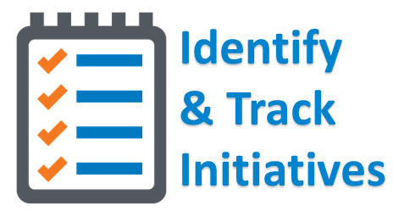
Additional Information:
If you have not yet completed a Local Government Operations GHG inventory, the CSC Local Government Operations Greenhouse Gas Accounting Tool is available to local governments in New York State. The tool helps users to develop a baseline GHG inventory of local government operations. Additional resources for GHG inventories for local government operations and the community are available for download on the Mid-Hudson CSC website.

Credits & Acknowledgements
[Local Government Officials and Staff]
- [Acknowledgement – Name and Title]
- [Acknowledgement – Name and Title]
- [Acknowledgement – Name and Title]
- [Acknowledgement – Name and Title]
- [Acknowledgement – Name and Title]
[Community Stakeholders]
- [Acknowledgement – Name and Title]
- [Acknowledgement – Name and Title]
- [Acknowledgement – Name and Title]
- [Acknowledgement – Name and Title]
- [Acknowledgement – Name and Title]

[Plan Contributors]
- [Acknowledgement – Name and Title]
- [Acknowledgement – Name and Title]
- [Acknowledgement – Name and Title]
- [Acknowledgement – Name and Title]

[External Agencies and Partners]
- [Acknowledgement – Name and Title]
- [Acknowledgement – Name and Title]
- New York State Department of Environmental Conservation
- New York State Energy and Research Development Authority
- New York State Climate Smart Communities
- VHB Engineering, Surveying and Landscape Architecture, P.C.

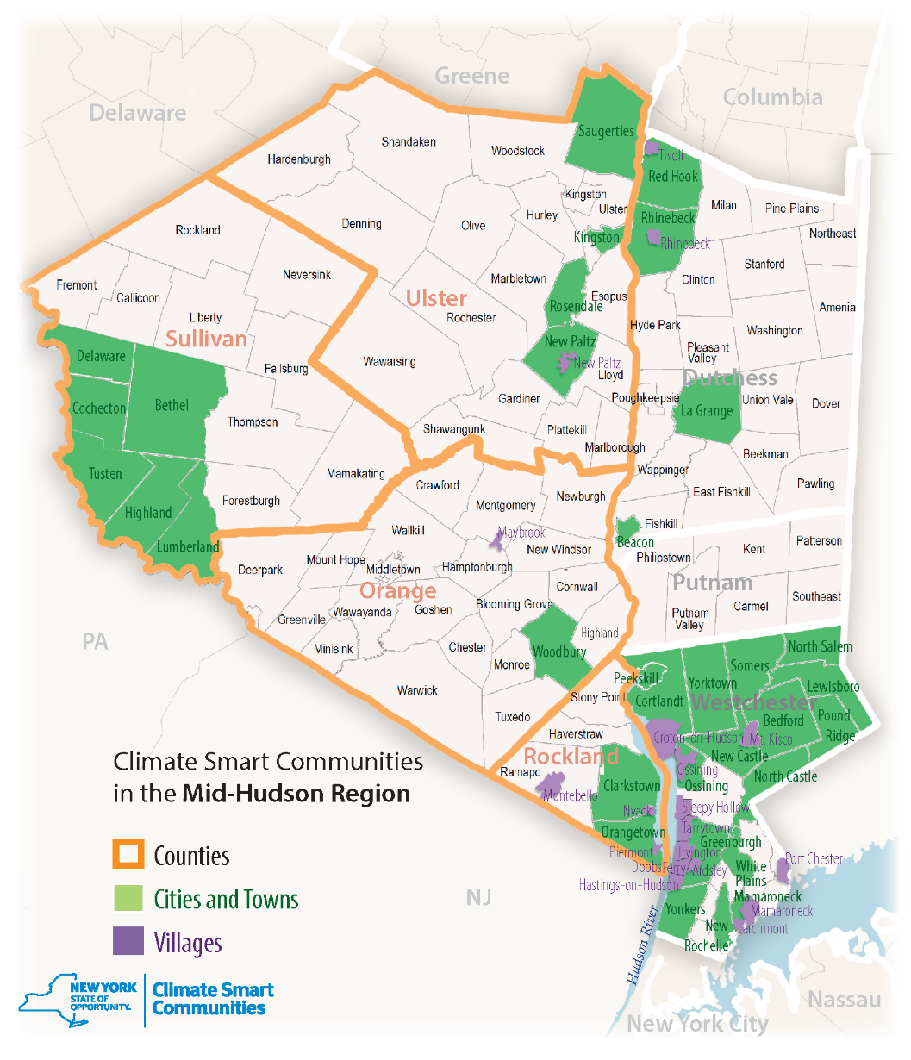
In 2009, New York State established the Climate Smart Communities (CSC) program as a unique state and local partnership to reduce greenhouse gas emissions, save taxpayer dollars and advance community goals for health and safety, economic vitality, energy independence and quality of life. This partnership includes six New York State Agencies that jointly sponsored the CSC Program, including the New York State Energy Research and Development Authority (NYSERDA), the Department of State, the Department of Environmental Conservation, the Department of Health, the Department of Transportation, and the Public Service Commission.

Figure 1: [Insert community map or photo here]
Table of Contents
Executive Summary 5
Introduction 6
CAP Process, Goals & GHG Reduction Targets 7
Current Climate Protection Initiatives 8
Community GHG Inventory Assessment 9
Local Government GHG Inventory Assessment 10
EX: Focus Area - Transportation 11
EX: Focus Area – Built Environment 13
EX: Focus Area – Waste & Recycling 15
EX: Focus Area – Renewable Energy 17
Optional Focus Area 19
Initiative Prioritization 22
Built Environment Priorities 24
Waste & Recycling Priorities 25
Renewable Energy Priorities 26
Moving Forward 28

Executive Summary
New York State (NYS) is already experiencing the impacts of climate change and has made climate mitigation one of the top priorities for the state. Over 130 local governments have adopted the NYS Climate Smart Communities (CSC) Pledge to reduce greenhouse gas (GHG) emissions and prepare for the effects of a changing climate. The [NAME OF LOCAL GOVERNMENT] is joining other communities to lead the way by launching Climate Action Plans to strategically implement actions that will result in reduced energy demand and GHG emissions in across five focus areas.
The creation of a Climate Action Plan for [NAME OF LOCAL GOVERNMENT] will not only address climate protection, but it will also result in energy savings and advance community goals for public health and safety. By choosing to act now, the [NAME OF LOCAL GOVERNMENT] is taking a leadership role in mitigating the impacts of climate change.
_ _ _ _ _ _ _ _ _ _ _ _ _ _ _ _ _ _ _ _ _ _ _ _ _ _ _ _ _ _ _ _ _ _ _ _ _ _ __ _ _ _ _ _ _ _ _ _ _ _ _ _ _ _ _ _ _ _ _ _ _ _ _ _ _ _ _ _ _ _ _ __ _ _ _ _ _ _ _ _ _ _ _ _ _ _ _ _ _ _ _ _ _ _ _ _ _ _ _ _ _ _ _ _ _ _ _ _ _ __ _ _ _ _ _ _ _ _ _ _ _ _ _ _ _ _ _ _ _ _ _ _ _ _ _ _ _ _ _ _ _ _ _ _ _ _ _ __ _ _ _ _ _ _ _ _ _ _ _ _ _ _ _ _ _ _ _ _ _ _ _ _ _ _ _ _ _ _ _ _ _ _ _ _ _ __ _ _ _ _ _ _ _ _ _ _ _ _ _ _ _ _ _ _ _ _ _ _ _ _ _ _ _ _ _ _ _ _ _ _ _ _ _ __ _ _ _ _ _ _ _ _ _ _ _ _ _ _ _ _ _ _ _ _ _ _ _ _ _ _ _ _ _ _ _ _ _ _ _ _ _ __ _ _ _ _ _ _ _ _ _ _ _ _ _ _ _ _ _ _ _ _ _ _ _ _ _ _ _ _ _ _ _ _ _ _ _ _ _ __ _ _ _ _ _ _ _ _ _ _ _ _ _ _ _ _ _ _ _ _ _ _ _ _ _ _ _ _ _ _ _ _ _ _ _ _ _ __ _ _ _ _ _ _ _ _ _ _ _ _ _ _ _ _ _ _ _ _ _ _ _ _ _ _ _ _ _ _ _ _ _ _ _ _ _ __ _ _ _ _ _ _ _ _ _ _ _ _ _ _ _ _ _ _ _ _ _ _ _ _ _ _ _ _ _ _ _ _ _ _ _ _ _ _ _ _ _ _ _ _ _ _ __ _ _ _ _ _ _ _ _ _ _ _ _ _ _ _ _ _ _ _ _ _ _ _ _ _ _ _ _ _ _ _ _ _ _ _ _ _ __ _ _ _ _ _ _ _ _ _ _ _ _ _ _ _ _ _ _ _ _ _ _ _ _ _ _ _ _ _ _ _ _ _ _ _ _ _ __ _ _ _ _ _ _ _ _ _ _ _ _ _ _ _ _ _ _ _ _ _ _ _ _ _ _ _ _ _ _ _ _ _ _ _ _ _ __ _ _ _ _ _ _ _ _ _ _ _ _ _ _ _ _ _ _ _ _ _ _ _ _ _ _ _ _ _ _ _ _ _ _ __ _ _ _ _ _ _ _ _ _ _ _ _ _ _ _ _ _ _ _ _ _ _ _ _ _ _ _ _ _ _ _ _ _ _ _ _ _ __ _ _ _ _ _ _ _ _ _ _ _ _ _ _ _ _ _ _ _ _ _ _ _ _ _ _ _ _ _ _ _ _ _ _ _ _ _ __ _ _ _ _ _ _ _ _ _ _ _ _ _ _ _ _ _ _ _ _ _ _ _ _ _ _ _ _ _ _ _ _ _ _ _ _ _ __ _ _ _ _ _ _ _ _ _ _ _ _ _ _ _ _ _ _ _ _ _ _ _ _ _ _ _ _ _ _ _ _ _ _ _ _ _ __ _ _ _ _ _ _ _ _ _ _ _ _ _ _ _ _ _ _ _ _ _ _ _ _ _ _ _ _ _ _ _ _ _ _ _ _ _ __ _ _ _ _ _ _ _ _ _ _ _ _ _ _ _ _ _ _ _ _ _ _ _ _ _ _ _ _ _ _ _ _ _ _ _ _ _ __ _ _ _ _ _ _ _ _ _ _ _ _ _ _ _ _ _ _ _ _ _ _ _ _ _ _ _ _ _ _ _ _ _ _ _ _ _ __ _ _ _ _ _ _ _ _ _ _ _ _ _ _ _ _ _ _ _ _ _ _ _ _ _ _ _ _ _ _ _ _ _ _ _ _ _ __ _ _ _ _ _ _ _ _ _ _ _ _ _ _ _ _ _ _ _ _ _ _ _ _ _ _ _ _ _ _ _ _ _ _ _ _ _ __ _ _ _ _ _ _ _ _ _ _ _ _ _ _

Introduction

Call for Local Climate Action
Given the overwhelming consensus that greenhouse gas (GHG) emissions are causing the climate to change, the [NAME OF LOCAL GOVERNMENT] is joining an increasing number of local governments in New York State who are committed to addressing GHG emissions at the local level. The [NAME OF LOCAL GOVERNMENT] recognizes the risk that climate change poses to its community, and is taking action to reduce the GHG emissions through the initiatives laid out in this Climate Action Plan.

Benefits of Climate Action Planning
This Climate Action Plan takes advantage of common sense approaches to improve air quality, lower energy costs, improve transportation and accessibility, reduce the community’s carbon footprint and benefit [NAME OF LOCAL GOVERNMENT] for years to come. While the [NAME OF LOCAL GOVERNMENT] cannot address climate change by itself, government policies and practices can dramatically reduce GHG emissions from a range of sources in the community.

Climate Action Plan Focus Areas
The Climate Action Plan identifies GHG emissions resulting from local government operations and community-wide activities within the [NAME OF LOCAL GOVERNMENT]. It addresses the major sources of emissions in focus areas and sets objectives and strategies that both the [NAME OF LOCAL GOVERNMENT] and community can implement to achieve greenhouse gas reductions. _ _ _ _ _ _ _ _ _ _ _ _ _ _ _ _ _ _ __ _ _ _ _ _ _ _ _ _ _ _ _ _ _ _ _ _ _ _ _ _ _ _ _ _ _ _ _ _ _ _ _ _ _ _ _ _ _ __ _ _ _ _ _ _ _ _ _ __ _ _ _ _ _ _ _ _ _ _ _ _ _ _ _ _ _ _ _ _ _ _ _ _ _ _ _ _ _ _ _ _ _ _ _ _ __ _ _ _ _ _ _ _ _ _ __ _ _ _ _ _ _ _ _ _ _ _ _ _ _ _ _ _ _ __ _ _ _ _ _ _ _ _ _ _ _ _ _ _ _ _ _ __ _ _ _ _ _ _ _ _ _ _ _ _ _ _ _ _ _ _ _ _ _ _ _ _ _ _ _ _ _ _ _ _ _ _ _ _ _ _ __ _ _ _ _ _ _ _ _ _ __ _ _ _ _ _ _ _ _ _ _ _ _ _ _ _ _ _ _ _ _ _ _ _ _ _ _ _ _ _ _ _ _ _ _ _ _ __ _ _ _ _ _ _ _ _ _ __ _ _ _ _ _ _ _ _ _ _ _ _ _ _ _ _ _ _ __ __ _ _ _ _ _ _ _ _ _ __ _ _ _ _ _ _ _ _ _ _ _ _ _ _ _ _ _ _ __ _ _ _ _ _ _ _ _ _ _ _ _ _ _ _ _ _ __ _ _ _ _ _ _ _ _ _ _ _ _ _ _ _ _ _ _ _ _ _ _ _ _ _ _ _ _ _ _ _ _ _ _ _ _ _ _ __ _ _ _ _ _ _ _ _ _ __ _ _ _ _ _ _ _ _ _ _ _ _ _ _ _ _ _ _ _ _ _ _ _ _ _ _ _ _ _ _ _ _ _ _ _ _ __ _ _ _ _ _ _ _ _ _ __ _ _ _ _ _ _ _ _ _ _ _ _ _ _ _ _ _ _ __ __ _ _ _ _ _ _ _ _ _ __ _ _ _ _ _ _ _ _ _ _ _ _ _ _ _ _ _ _ __ _ _ _ _ _ _ _ _ _ _ _ _ _ _ _ _ _ __ _ _ _ _ _ _ _ _ _ _ _ _ _ _ _ _ _ _ _ _ _ _ _ _ _ _ _ _ _ _ _ _ _ _ _ _ _ _ __ _ _ _ _ _ _ _ _ _ __ _ _ _ _ _ _ _ _ _ _ _ _ _ _ _ _ _ _ _ _ _ _ _ _ _ _ _ _ _ _ _ _ _ _ _ _ __ _ _ _ _ _ _ _ _ _ __ _ _ _ _ _ _ _ _ _ _ _ _ _ _ _ _ _ _ _

CAP Process, Goals & GHG Reduction Targets

Local Climate Action Planning Process
_ _ _ _ _ _ _ _ _ _ _ _ _ _ _ _ _ _ _ __ _ _ _ _ _ _ _ _ _ _ _ _ _ _ _ _ _ _ _ _ _ _ _ _ _ _ _ _ _ _ _ _ _ _ _ _ _ _ __ _ _ _ _ _ _ _ _ _ __ _ _ _ _ _ _ _ _ _ _ _ _ _ _ _ _ _ _ _ _ _ _ _ _ _ _ _ _ _ _ _ _ _ _ _ _ __ _ _ _ _ _ _ _ _ _ __ _ _ _ _ _ _ _ _ _ _ _ _ _ _ _ _ _ _ __ _ _ _ _ _ _ _ _ _ _ _ _ _ _ _ _ _ _ __ _ _ _ _ _ _ _ _ _ _ _ _ _ _ _ _ _ _ _ _ _ _ _ _ _ _ _ _ _ _ _ _ _ _ _ _ _ _ __ _ _ _ _ _ _ _ _ _ __ _ _ _ _ _ _ _ _ _ _ _ _ _ _ _ _ _ _ _ _ _ _ _ _ _ _ _ _ _ _ _ _ _ _ _ _ __ _ _ _ _ _ _ _ _ _ __ _ _ _ _ _ _ _ _ _ _ _ _ _ _ _ _ _ _ _

CAP Framework and Goals
The [NAME OF LOCAL GOVERNMENT] completed a greenhouse gas (GHG) emissions inventory to identify the largest sectors of emissions. Based on the GHG baseline analysis and input from community stakeholders, focus areas were developed to streamline and cross-coordinate actions between the local government and the community to reduce emissions across these sectors. The [NAME OF LOCAL GOVERNMENT] Climate Action Plan creates a framework for documenting and coordinating efforts by providing information about each initiatives’ estimated implementation timeframe, costs, and potential leaders and partners. Each focus area includes a list of actions that will help to achieve the goals and reduction targets established during the climate action planning process.

GHG Reduction Targets
The Climate Action Plan is a critical component of a comprehensive approach to reducing [NAME OF LOCAL GOVERNMENT] emissions. The [NAME OF LOCAL GOVERNMENT] is committed to achieving an overall GHG emissions reduction target of [%] percent below [Keywords] emission levels by [TARGET YYYY] This reduction target can be met if each focus area implements the list of recommended actions to achieve the reduction target set for that sector. The goals and reduction targets for each of the focus areas are summarized in the following outline.

Current Climate Protection Initiatives
Climate change is not always separate from the other challenges faced by the [NAME OF LOCAL GOVERNMENT], such as budget constraints, water quality, infrastructure maintenance, or community health. Climate change is a result of the land use, transportation and energy use decisions that have evolved over generations and requires coordinated solutions. The [NAME OF LOCAL GOVERNMENT] has already begun to reduce greenhouse gas (GHG) emissions through a variety of plans, programs, policies and actions as demonstrated in the Climate Protection Timeline (Figure 2). With these milestones completed and a Climate Action Plan to guide the way, the [NAME OF LOCAL GOVERNMENT] is better positioned to implement initiatives to reduce energy use, costs and GHG emissions for local government operations and the community.
[RIGHT CLICK TO COPY & PASTE A TEXT BOX. ENTER INITIATIVE & MOVE TO YEAR COMPLETED.]
[NAME OF LOCAL GOVERNMENT]
Climate Protection Timeline
2008 2009 2010 2011 2012 2013
Plans & Studies
Programs
Policies
Climate Initiatives
FIGURE 2: [NAME OF LOCAL GOVERNMENT] TIMELINE OF CLIMATE PROTECTION
EX: Adopted a Green Building Code
EX: Completed GHG Inventory
Participated in Regional Sustainability Plan
Adopted the CSC Pledge

Community GHG Inventory Assessment

The community GHG inventory is an important component of the [NAME OF LOCAL GOVERNMENT] Climate Action Plan. It identifies sources of emissions from community activities and establishes a baseline from which future emissions reductions and progress can be measured. New York State conducted regional greenhouse gas (GHG) emissions inventories for the baseline year 2010. The GHG emissions from [NAME OF LOCAL GOVERNMENT] were calculated as a part of the regional GHG inventory for each of the community sectors listed in Table 1.
Figure 3 shows the breakdown of GHG emissions by sector. [SECTOR NAME] is [NAME OF LOCAL GOVERNMENT]’s largest source of GHG emissions, comprising approximately [%] of 2010 community emissions. The emissions come from fossil fuels used in [SECTOR EXAMPLES]. Improving the efficiency of [SECTOR EXAMPLE] will significantly reduce the climate impact of [SECTOR NAME].

_ _ _ _ _ _ _ _ _ _ _ _ _ _ _ _ _ _ _ _ _ _ _ _ _ _ __ _ _ _ _ _ _ _ _ _ _ _ _ _ _ _ _ _ _ _ _ _ _ _ _ _ _ _ _ _ _ _ _ _ _ _ _ _ __ _ _ _ _ _ _ _ _ _ _ _ _ _ _ _ _ _ _ _ _ _ _ _ _ _ _ _ _ _ _ _ _ _ _ _ _ _ __ _ _ _ _ _ _ _ _ _ _ _ _ _ _ _ _ _ _ _ _ _ _ _ _ _ _ _ _ _ _ _ _ _ _ _ _ _ __ _ _ _ _ _ _ _ _ _ _ _ _ _ _ _ _ _ _ _ _ _ _ _ _ _ _ _ _ _ _ _ _ _ _ _ _ _ __ _ _ _ _ _ _ _ _ _ _ _ _ _ _ _ _ _ _ _ _ _ _ _ _ _ _ _ _ _ _ _ _ _ _ _ _ _ __ _ _ _ _ _ _ _ _ _ _ _ _ _ _ _ _ _ _ _ _ _ _ _ _ _ _ _ _ _ _ _ _ _ _ _ _ _ __ _ _ _ _ _ _ _ _ _ _ _ _ _ _ _ _ _ _ _ _ _ _ _ _ _ _ _ _ _ _ _ _ _ _ _ _ _ __ _ _ _ _ _ _ _ _ _ _ _ _ _ _ _ _ _ _ _ _ _ _ _ _ _ _ _ _ _ _ _ _ _ _ _ _ _ __ _ _ _ _ _ _ _ _ _ _ _ _ _ _ _ _ _ _ _ _ _ _ _ _ _ _ _ _ _ _ _ _ _ _ _ _ _ __

Local Government GHG Inventory Assessment

A local government operations GHG inventory was conducted for the [NAME OF LOCAL GOVERNMENT] for the baseline year [LOCAL GOVERNMENT BASELINE YYYY]. The local government GHG emissions inventory accounts for emissions associated with facilities, vehicles, and other processes that are owned and operated by [NAME OF LOCAL GOVERNMENT]. The identified sources of emissions related to government operations are listed in the Table 2.
Figure 4 shows the GHG emissions resulting from the day-to-day operations of a local government. [SECTOR NAME] is the largest source of GHG emissions, comprising approximately [%] of [LOCAL GOVERNMENT BASELINE YYYY] of [NAME OF LOCAL GOVERNMENT] emissions. The emissions come from fossil fuels used in [SECTOR EXAMPLES]. Improving the efficiency of [SECTOR EXAMPLE] will significantly reduce the climate impact of [SECTOR NAME]. _ _ _ _ _ _ _ _ _ _ _ _ _ _ _ _ _ _ _ _ _ _ _ _ _ _ _ _ _ __ _ _ _ _ _ _ _ _ _ _ _ _ _ _ _ _ _ _ _ _ _ _ _ _ _ _ _ _ _ _ _ _ _ _ _ _ _ __ _ _ _ _ _ _ _ _ _ _ _ _ _ _ _ _ _ _ _ _ _ _ _ _ _ _ _ _ _ _ _ _ _ _ _ _ _ __ _ _ _ _ _ _ _ _ _ _ _ _ _ _ _ _ _ _ _ _ _ _ _ _ _ _ _ _ _ _ _ _ _ _ _ _ _ __ _ _ _ _ _ _ _ _ _ _ _ _ _ _ _ _ _ _ _ _ _ _ _ _ _ _ _ _ _ _ _ _ _ _ _ _ _ _ __ _ _ _ _ _ _ _ _ _ _ _ __ _ _ _ _ _ _ _ _ _ _ _ _ _ _ _ _ _ _ _ _ _ _ _ _ _ _ _ _ __ _ _ _ _ _ _ _ _ _ _ _ _ _ _ _ _ _ _ _ _ _ _ _ _ _ _ _ _ _ _ _ _ _ _ _ _ _ __ _ _ _ _ _ _ _ _ _ _ _ _ _ _ _ _ _ _ _ _ _ _ _ _ _ _ _ _ _ _ _ _ _ _ _ _ _ __ _ _ _ _ _ _ _ _ _ _ _ _ _ _ _ _ _ _ _ _ _ _ _ _ _ _ _ _ _ _ _ _ _ _ _ _ _ __ _ _ _ _ _ _ _ _ _ _ _ _ _ _ _ __ _ _ _ _ _ _ _ _ _ _ _ _ _ _ _ _ _ _ _ _ _ _ _ _ _ _ _ _ _ _ _ _ _ _ _ _ _ __ _ _ _ _ _ _ _ _ _ _ _ _ _ _ _ _ _ _ _ _ _ _ _ _ _ _ _ _ _ _ _ _ _ _ _ _ _ __ _ _ _ _ _ _ _ _ _ _ _ _ _ _ _ _ _ _ _ _ _ _ _ _ _ _ _ _ _ _ _ _ _ _ _ _ _ _ _ _ _ _ _ _ _ _ _ _ _ _ _ _ _ _ _ _ _ __ _ _ _ _ _ _ _ _ _ _

Emissions from transportation are a common sight to nearly everyone in [NAME OF LOCAL GOVERNMENT]. Besides emitting greenhouse gases, transportation fossil fuels cause air pollution and affect our health. The Transportation sector accounts for all [mobile fuel use for passenger vehicles, freight trucks, railways, aviation, and marine transit for local government operations and the community]. Transportation accounts for [%] of [NAME OF LOCAL GOVERNMENT]’s total GHG emissions. The [NAME OF LOCAL GOVERNMENT]’s goals are to [reduce the number of passenger vehicles on the road, decrease vehicle miles traveled (VMT), and increase access to electric vehicle or alternative fueling infrastructure]. The implementation of the actions listed in the CAP will position [NAME OF LOCAL GOVERNMENT] to make substantial progress toward the overall emissions reduction target for transportation to achieve a [%] percent reduction by [TARGET YYYY].

EX: Focus Area - Transportation

100%
50%
0%

EX: Focus Area - Transportation
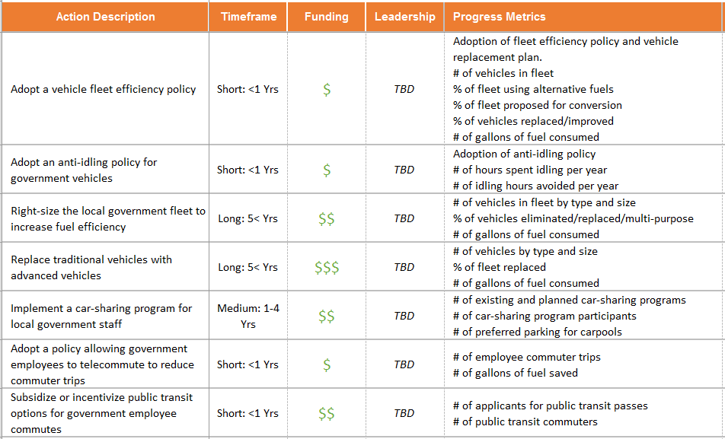
The Built Environment includes [all electricity or energy used residential, commercial, and industrial, government buildings or facilities]. The Built Environment accounts for [%] of [NAME OF LOCAL GOVERNMENT]’s total GHG emissions. The [NAME OF LOCAL GOVERNMENT]’s goals are to [increase energy efficiency of single-family homes, multi-family buildings, commercial businesses and government-owned buildings]. The implementation of the actions listed in the CAP will position [NAME OF LOCAL GOVERNMENT] to make substantial progress toward the overall emissions reduction target for the Built Environment to achieve a [%] percent reduction below by [TARGET YYYY]._ _ _ _ _ _ _ _ _ _ _ _ _ _ __ _ _ _ _ _ _ _ _ _ _ _ _ _ _ _ _ _ _ _ _ _ _ _ _ _ _ _ _ _ _ _ _ _ _ _ _ _ __ _ _ _ _ _ _ _ _ _ _ _ _ _ _ _ _ _ _ _ _ _ _ _ _ _ _ _ _ _ _ _ _ _ _ _ _ _ __ _ _ _ _ _ _ _ _ _ _ _ _ _ _ _ _ _ _ _ _ _ _ _ _ _ _ _ _ _ _ _ _ _ _ _ _ _ __ _ _ _ _ _ _ _ _ _ _ _ _ _ _ _ _ _ _ _ _ _ _ _ _ _ _ _ _ _ _ _ _ _ _ _ _ _ __ _ _ _ _ _ _ _ _ _ _ _ _ _ _ _ _ _ _ _ _ _ _ _ _ _ _ _ _ _ _ _ _ _ _ _ _ _ __ _ _ _ _ _ _ _ _ _ _ _ _ _ _ _ _ _ _ _ _ _ _ _ _ _ _ _ _ _ _ _ _ _ _ _ _ _ __ _ _ _ _ _ _ _ _ _ _ _ _ _ _ _ _ _ _ _ _ _ _ _ _ _ _ _ _ _ _ _ _ _ _ _ _ _ __ _ _ _ _ _ _ _ _ _ _ _ _ _ _ _ _ _ _ _ _ _ _ _ _ _ _ _ _ _ _ _ _ _ _ _ _ _ __ _ _ _ _ _ _ _ _ _ _ _ _ _ _ _ _ _ _ _ _ _ _ _ _ _ _ _ _ _ _ _ _ _ _ _ _ _ __ _ _ _ _ _ _ _ _ _ _ _ _ _ _ _ _ _ _ _ _ _ _ _ _ _ _ _ _ _ _ _ _ _ _ _ _ _ __ _ _ _ _ _ _ _ _ _ _ _ _ _ _ _ _ _ _ _ _ _ _ _ _ _ _ _ _ _ _ _ _ _ _ _ _ _ __ _ _ _ _ _ _ _ _ _ _ _ _ _ _

100%
50%
0%

EX: Focus Area – Built Environment

EX: Focus Area – Built Environment
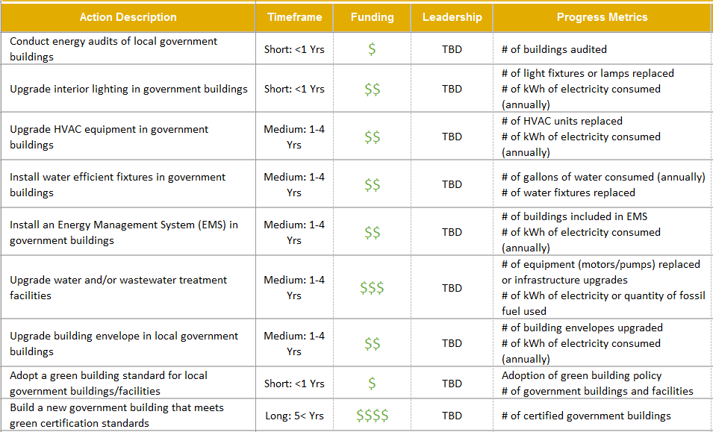
Community waste includes [all non-energy, greenhouse gas emissions from landfills and wastewater treatment plants]. Waste accounts for [%] of [NAME OF LOCAL GOVERNMENT]’s total GHG emissions. The [NAME OF LOCAL GOVERNMENT]’s goals are to [reduce the amount of solid waste sent to landfills by composting and recycling, be environmentally conscious consumers, and increase operational and energy efficiency of the wastewater treatment plant]. The implementation of the actions listed in the CAP will position [NAME OF LOCAL GOVERNMENT] to make substantial progress toward the overall emissions reduction target for reducing waste to achieve a [%] percent reduction below by [TARGET YYYY]._ _ _ _ __ _ _ _ _ _ _ _ _ _ _ _ _ _ _ _ _ _ _ _ _ _ _ _ _ _ _ _ _ _ _ _ _ _ _ _ _ _ __ _ _ _ _ _ _ _ _ _ _ _ _ _ _ _ _ _ _ _ _ _ _ _ _ _ _ _ _ _ _ _ _ _ _ _ _ _ __ _ _ _ _ _ _ _ _ _ _ _ _ _ _ _ _ _ _ _ _ _ _ _ _ _ _ _ _ _ _ _ _ _ _ _ _ _ __ _ _ _ _ _ _ _ _ _ _ _ _ _ _ _ _ _ _ _ _ _ _ _ _ _ _ _ _ _ _ _ _ _ _ _ _ _ __ _ _ _ _ _ _ _ _ _ _ _ _ _ _ _ _ _ _ _ _ _ _ _ _ _ _ _ _ _ _ _ _ _ _ _ _ _ __ _ _ _ _ _ _ _ _ _ _ _ _ _ _ _ _ _ _ _ _ _ _ _ _ _ _ _ _ _ _ _ _ _ _ _ _ _ __ _ _ _ _ _ _ _ _ _ _ _ _ _ _ _ _ _ _ _ _ _ _ _ _ _ _ _ _ _ _ _ _ _ _ _ _ _ __ _ _ _ _ _ _ _ _ _ _ _ _ _ _ _ _ _ _ _ _ _ _ _ _ _ _ _ _ _ _ _ _ _ _ _ _ _

EX: Focus Area – Waste & Recycling
100%
50%
0%
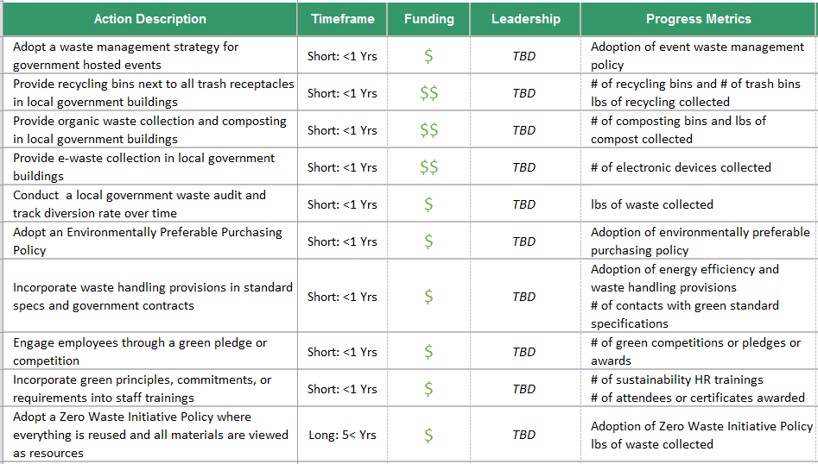

EX: Focus Area – Waste & Recycling

[Focus Area] includes [What are the primary sources of GHG emissions for this sector?]. [Focus Area] accounts for [%] of [NAME OF LOCAL GOVERNMENT]’s total GHG emissions. The [NAME OF LOCAL GOVERNMENT]’s goals are to [What are the goals for reducing emissions in this Focus Area?] The implementation of the actions listed in the CAP will position [NAME OF LOCAL GOVERNMENT] to make substantial progress toward the overall emissions reduction target for the [Focus Area] to achieve a [%] percent reduction below by [TARGET YYYY]._ _ _ _ _ _ _ _ _ _ _ _ _ __ _ _ _ _ _ _ _ _ _ _ _ _ _ _ _ _ _ _ _ _ _ _ _ _ _ _ _ _ _ _ _ _ _ _ _ _ _ __ _ _ _ _ _ _ _ _ _ _ _ _ _ _ _ _ _ _ _ _ _ _ _ _ _ _ _ _ _ _ _ _ _ _ _ _ _ __ _ _ _ _ _ _ _ _ _ _ _ _ _ _ _ _ _ _ _ _ _ _ _ _ _ _ _ _ _ _ _ _ _ _ _ _ _ __ _ _ _ _ _ _ _ _ _ _ _ _ _ _ _ _ _ _ _ _ _ _ _ _ _ _ _ _ _ _ _ _ _ _ _ _ _ __ _ _ _ _ _ _ _ _ _ _ _ _ _ _ _ _ _ _ _ _ _ _ _ _ _ _ _ _ _ _ _ _ _ _ _ _ _ __ _ _ _ _ _ _ _ _ _ _ _ _ _ _ _ _ _ _ _ _ _ _ _ _ _ _ _ _ _ _ _ _ _ _ _ _ _ __ _ _ _ _ _ _ _ _ _ _ _ _ _ _ _ _ _ _ _ _ _ _ _ _ _ _ _ _ _ _ _ _ _ _ _ _ _ __ _ _ _ _ _ _ _ _ _ _ _ _ _ _ _ _ _ _ _ _ _ _ _ _ _ _ _ _ _ _ _ _ _ _ _ _ _ __ _ _ _ _ _ __ _ _ _ _ _ _ _ _ _ _ _ _ _ _ _ __ _ _ _ _ _ _ _ _ _ _ _ _ _ _ _ _ _ _ _ _ _ _ _ _ _ _ _ _ _ _ _ _ _ _ _ _ _ __ _ _ _ _ _ _ _ _ _ _ _ _ _ _ _ _ _ _ _ _ _ _ _ _ _ _ _ _ _ _ _ _ _ _ _ _ __ _ _ _ _ _ _ _ _ _

EX: Focus Area – Renewable Energy
100%
50%
0%
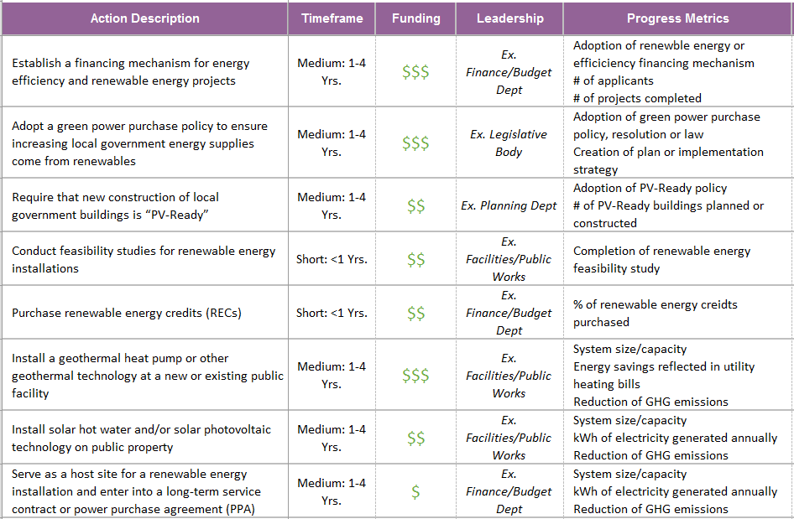

EX: Focus Area – Renewable Energy
[Focus Area] includes [What are the primary sources of GHG emissions for this sector?]. [Focus Area] accounts for [%] of [NAME OF LOCAL GOVERNMENT]’s total GHG emissions. The [NAME OF LOCAL GOVERNMENT]’s goals are to [What are the goals for reducing emissions in this Focus Area?] The implementation of the actions listed in the CAP will position [NAME OF LOCAL GOVERNMENT] to make substantial progress toward the overall emissions reduction target for the [Focus Area] to achieve a [%] percent reduction below by [TARGET YYYY]._ _ _ _ _ _ _ _ _ _ _ _ _ _ _ _ _ _ _ _ _ _ __ _ _ _ _ _ _ _ _ _ _ _ _ _ _ _ _ _ _ _ _ _ _ _ _ _ _ _ _ _ _ _ _ _ _ _ _ _ __ _ _ _ _ _ _ _ _ _ _ _ _ _ _ _ _ _ _ _ _ _ _ _ _ _ _ _ _ _ _ _ _ _ _ _ _ _ __ _ _ _ _ _ _ _ _ _ _ _ _ _ _ _ _ _ _ _ _ _ _ _ _ _ _ _ _ _ _ _ _ _ _ _ _ _ __ _ _ _ _ _ _ _ _ _ _ _ _ _ _ _ _ _ _ _ _ _ _ _ _ _ _ _ _ _ _ _ _ _ _ _ _ _ __ _ _ _ _ _ _ _ _ _ _ _ _ _ _ _ _ _ _ _ _ _ _ _ _ _ _ _ _ _ _ _ _ _ _ _ _ _ __ _ _ _ _ _ _ _ _ _ _ _ _ _ _ _ _ _ _ _ _ _ _ _ _ _ _ _ _ _ _ _ _ _ _ _ _ _ __ _ _ _ _ _ _ _ _ _ _ _ _ _ _ _ _ _ _ _ _ _ _ _ _ _ _ _ _ _ _ _ _ _ _ _ _ _ __ _ _ _ _ _ _ _ _ _ _ _ _ _ _

Optional Focus Area
100%
75%
50%
25%

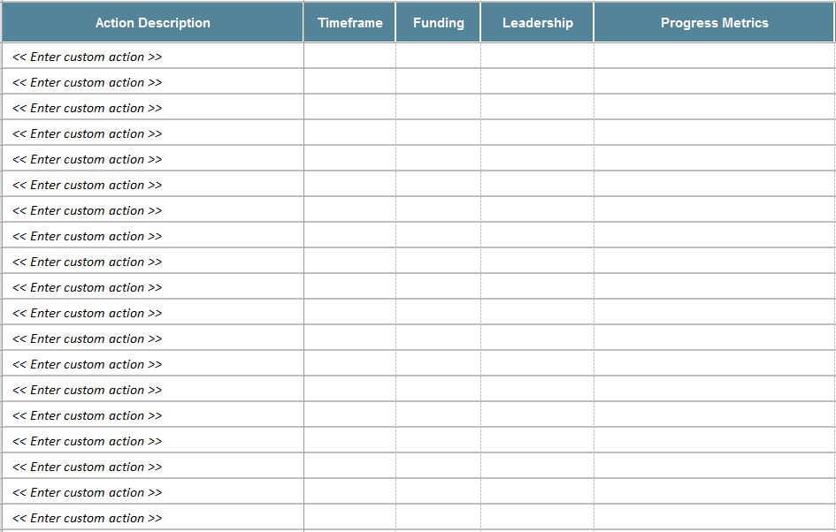

Optional Focus Area
The Prioritization Tool is an Excel-based spreadsheet that is designed to help a local government to evaluate initiatives and prioritize implementation using a point system and a weighted score. Evaluation criteria can be established to determine local priorities (e.g. local job creation, funding feasibility, GHG reductions, etc.). Initiatives can then be scored based on their impact in each of the categories. Points are added together to see which initiatives received the highest score. Click on the Prioritization Tool icon to open the Excel document and read through the 2 step instructions (summarized below):

STEP 1 – Establish the Evaluation Criteria:
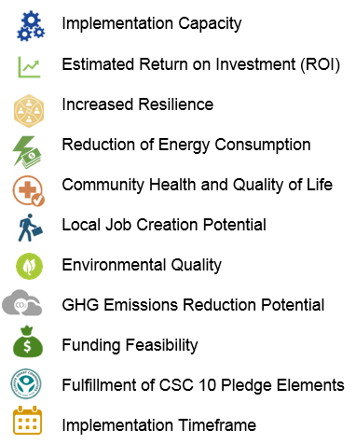
The Evaluation Criteria tab lists examples of local priorities and possible points and weighted scores for each category. There are 11 evaluation criteria examples built into the Prioritization Tool. Local governments can revise evaluation criteria and update point values to customize the Prioritization Tool calculations to reflect local priorities.
11 EVALUATION CRITERIA:
Use the Prioritization Tool to Evaluate Initiatives [DELETE PAGE WHEN FINISHED]
STEP 2 – Prioritize the Initiatives:
Once the evaluation criteria have been established, the local government can use the Prioritization Tool to score initiatives in each focus area. The Prioritization Tool should be updated to align with the current list of initiatives in your CAP focus areas. Once each initiative has been scored for all focus areas, the results can be copied from Excel and pasted into the CAP template. When pasting, choose the option to "Keep Source Formatting" and the Excel formatting will be preserved. Each focus area table can be pasted into the space provided in the CAP Template on pages 26 - 30. The CAP Template includes an explanation of this rating system on the next page (22), including the list of evaluation criteria and the methodology used in the Prioritization Tool.

NOTE: Evaluating initiatives through this process is not a perfect science, but it does provide a systematic framework for highlighting important initiatives that align with local priorities when there are hundreds of recommended programs and policies. While it does create a useful structure for reviewing the benefits and drawbacks associated with each, it can be challenging to score all initiatives objectively and consistently. If an initiative does not score well through this process, it does not mean that it should be ruled out as a priority. Some subjective decision-making will still need to be applied. For example, feasibility studies or greenhouse gas emissions inventories may receive a low score because they do not have direct impacts, but they are essential to the process and inform other initiatives. The evaluation process can be improved by clearly describing the initiatives in the Prioritization Tool and designating one leader to apply their best judgment consistently across initiatives.

Initiative Prioritization

Evaluation Criteria
Now that climate actions have been identified, one challenge was deciding where to start. Which action is the most important? How do we start implementing this plan? To address this challenge, the [NAME OF LOCAL GOVERNMENT] used a rating system to strategically determine which initiatives should be prioritized for implementation based on local goals and priorities. Evaluation criteria were established by the [NAME OF LOCAL GOVERNMENT] and its stakeholders to provide a framework for estimating benefits and identifying priority initiatives.

Scoring Methodology
All initiatives were scored against the evaluation criterion using a point system to assess the feasibility and impact of implementing an initiative. Weighted scores were added to evaluation criteria that are particularly important to the [NAME OF LOCAL GOVERNMENT] by multiplying the weighted score against the initiative’s points in that category. This process escalates initiatives that best align with local priorities to the top of the implementation list. The following pages reflect the total points and weighted scores for each initiative across all focus areas, ranked from highest to lowest.

The [NAME OF LOCAL GOVERNMENT]’s current evaluation criteria include the following:
Implementation Capacity
Estimated Return on Investment (ROI)
Increased Resilience
Reduction of Energy Consumption
Community Health and Quality of Life
Local Job Creation Potential
Environmental Quality
GHG Emissions Reduction Potential
Funding Feasibility
Fulfillment of CSC 10 Pledge Elements
Implementation Timeframe

WEIGHTED SCORE | TOTAL POINTS | ACTION DESCRIPTION
0 | 0 | Adopt a government vehicle fleet efficiency policy
0 | 0 | Adopt an anti-idling policy for government vehicles
0 | 0 | Right-size the local government fleet to increase fuel efficiency
0 | 0 | Replace government vehicles with electric or hybrid vehicles
0 | 0 | Replace government vehicles with alternative fuel vehicles
0 | 0 | Implement a car-sharing program for local government staff
0 | 0 | Adopt a policy allowing government employees to telecommute to reduce commuter trips
0 | 0 | Subsidize or incentivize public transit options for government employee commutes
0 | 0 | Engage government employees through a green pledge or competition
0 | 0 | Incorporate green practices into HR trainings for government employees
0 | 0 | Adopt green parking lot standards for transit-oriented developments (TOD) or municipal centers
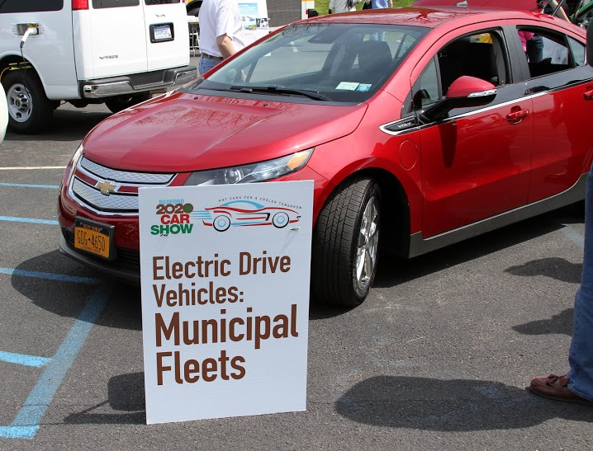
  - Transportation Priorities

Built Environment Priorities

WEIGHTED SCORE | TOTAL POINTS | ACTION DESCRIPTION
0 | 0 | Conduct energy audits of local government buildings
0 | 0 | Upgrade interior lighting in government buildings
0 | 0 | Upgrade HVAC equipment in government buildings
0 | 0 | Install water efficient fixtures in government buildings
0 | 0 | Install an Energy Management System (EMS) in government buildings
0 | 0 | Upgrade water and/or wastewater treatment facilities
0 | 0 | Upgrade building envelope in local government buildings
0 | 0 | Adopt a green building standard for local government buildings/facilities
0 | 0 | Build a new government building that meets green certification standards
0 | 0 | Convert government-owned streetlights to LED
0 | 0 | Convert government owned traffic signals to LED
0 | 0 | Reduce number of outdoor lighting fixtures
0 | 0 | Upgrade outdoor lighting (non streetlight/traffic signal) to more efficient and/or solar
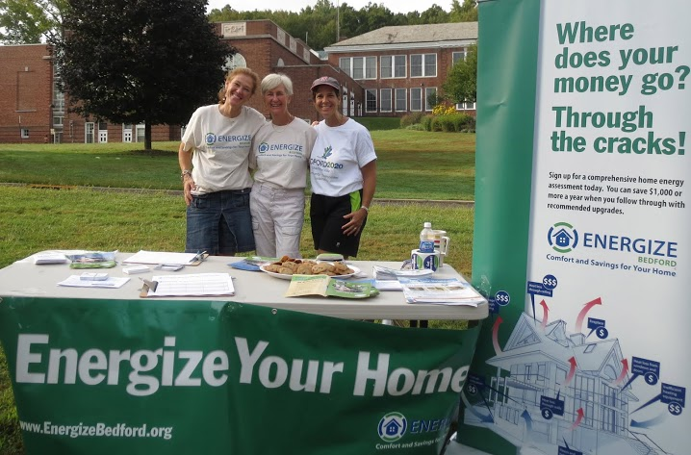
WEIGHTED SCORE | TOTAL POINTS | ACTION DESCRIPTION
0 | 0 | Adopt a waste management strategy for government hosted events
0 | 0 | Provide recycling bins next to all trash receptacles in local government buildings
0 | 0 | Provide composting in local government buildings
0 | 0 | Provide e-waste collection in local government buildings
0 | 0 | Conduct a local government waste audit and track diversion rate over time
0 | 0 | Adopt an Environmentally Preferable Purchasing Policy
0 | 0 | Incorporate waste handling provisions in standard specs and government contracts
0 | 0 | Engage employees through a green pledge or competition
0 | 0 | Incorporate green recycling practices into HR trainings for government employees
0 | 0 | Adopt a Zero Waste Initiative Policy where everything is reused and all materials are viewed as resources
0 | 0 | Discourage or Ban the Use of Plastic Bags
0 | 0 | Participate in the EPA WasteWise Program
0 | 0 | Implement a Pay-As-You-Throw Program
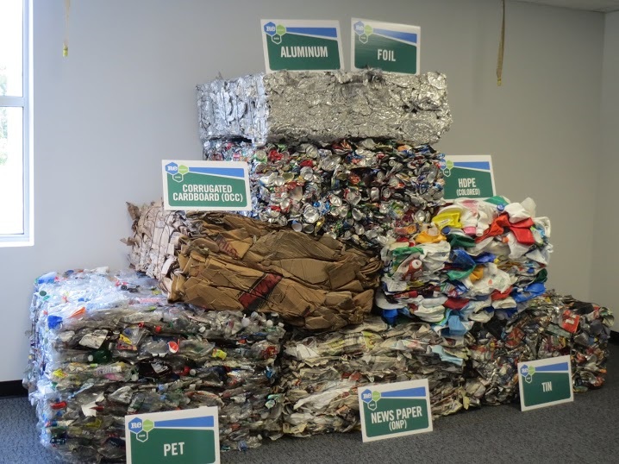

Waste & Recycling Priorities

Renewable Energy Priorities
WEIGHTED SCORE | TOTAL POINTS | ACTION DESCRIPTION
0 | 0 | << Enter custom action >>
0 | 0 | << Enter custom action >>
0 | 0 | << Enter custom action >>
0 | 0 | << Enter custom action >>
0 | 0 | << Enter custom action >>
0 | 0 | << Enter custom action >>
0 | 0 | << Enter custom action >>
0 | 0 | << Enter custom action >>
0 | 0 | << Enter custom action >>
0 | 0 | << Enter custom action >>
0 | 0 | << Enter custom action >>
0 | 0 | << Enter custom action >>
0 | 0 | << Enter custom action >>
0 | 0 | << Enter custom action >>
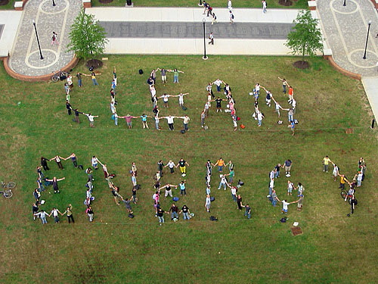
WEIGHTED SCORE | TOTAL POINTS | ACTION DESCRIPTION
0 | 0 | << Enter custom action >>
0 | 0 | << Enter custom action >>
0 | 0 | << Enter custom action >>
0 | 0 | << Enter custom action >>
0 | 0 | << Enter custom action >>
0 | 0 | << Enter custom action >>
0 | 0 | << Enter custom action >>
0 | 0 | << Enter custom action >>
0 | 0 | << Enter custom action >>
0 | 0 | << Enter custom action >>
0 | 0 | << Enter custom action >>
0 | 0 | << Enter custom action >>
0 | 0 | << Enter custom action >>
0 | 0 | << Enter custom action >>
  - Optional Focus Area Priorities

Moving Forward

Climate change mitigation may be a challenge, but it is also an opportunity to take action and make better energy choices that will make [NAME OF LOCAL GOVERNMENT] more stable and resilient in the future. Whether you are a local official, homeowner or renter, business owner or educational institution, this Climate Action Plan is a resource to all community stakeholders and offers the framework and resources needed to implement actions that will help the [NAME OF LOCAL GOVERNMENT] achieve the goals established for our community.
The [NAME OF LOCAL GOVERNMENT]’s Climate Action Plan has set an ambitious goal to achieve [%] precent reduction of greenhouse gas (GHG) emissions by [TARGET YYYY]. Using the greenhouse gas emission inventory as a foundation, this Climate Action Plan has outlined a collection of measures and policies that reduce GHG emissions. To maximize success in implementing this plan, the [NAME OF LOCAL GOVERNMENT] has included detailed information about the leadership and resources needed to take action and ranked initiatives according to our local priorities. With the Climate Action Plan as our guide, the [NAME OF LOCAL GOVERNMENT] can take effective action in climate change mitigation as we implement municipal and community-wide programs, projects and policies.
_ _ _ _ _ _ _ _ _ _ _ _ _ _ _ _ _ _ _ _ __ _ _ _ _ _ _ _ _ _ _ _ _ _ _ _ _ _ _ _ _ _ _ _ _ _ _ _ _ _ _ _ _ _ _ _ _ _ __ _ _ _ _ _ _ _ _ _ _ _ _ _ _ _ _ _ _ _ _ _ _ _ _ _ _ _ _ _ _ _ _ _ _ _ _ _ __ _ _ _ _ _ _ _ _ _ _ _ _ _ _ _ _ _ _ _ _ _ _ _ _ _ _ _ _ _ _ _ _ _ _ _ _ _ _ __ _ _ _ _ _ _ _ _ _ _ _ __ _ _ _ _ _ _ _ _ _ _ _ _ _ _ _ _ _ _ _ _ _ _ _ _ _ _ _ _ __ _ _ _ _ _ _ _ _ _ _ _ _ _ _ _ _ _ _ _ _ _ _ _ _ _ _ _ _ _ _ _ _ _ _ _ _ _ __ _ _ _ _ _ _ _ _ _ _ _ _ _ _ _ _ _ _ _ _ _ _ _ _ _ _ _ _ _ _ _ _ _ _ _ _ _ __ _ _ _ _ _ _ _ _ _ _ _ _ _ _ _ _ _ _ _ _ _ _ _ _ _ _ _ _ _ _ _ _ _ _ _ _ _ __ _ _ _ _ _ _ _ _ _ _ _ _ _ _ _ __ _ _ _ _ _ _ _ _ _ _ _ _ _ _ _ _ _ _ _ _ _ _ _ _ _ _ _ _ _ _ _ _ _ _ _ _ _ __ _ _ _ _ _ _ _ _ _ _ _ _ _ _ _ _ _ _ _ _ _ _ _ _ _ _ _ _ _ _ _ _ _ _ _ _ _ __ _ _ _ _ _ _ _ _ _ _ _ _ _ _ _ _ _ _ _ _ _ _ _ _ _ _ _ _ _ _ _ _ _ _ _ _ _ _ _ _ _ _ _ _ _ _ _ _ _ _ _ _ _ _ _ _ _ __ _ _ _ _ _ _ _ _ _ __ _ _ _ _ _ _ _ _ _ _ _ _ _ _ _ _ _ _ _ __ _ _ _ _ _ _ _ _ _ _ _ _ _ _ _ _ _ _ _ _ _ _ _ _ _ _ _ _ _ _ _ _ _ _ _ _ _ __ _ _ _ _ _ _ _ _ _ _ _ _ _ _ _ _ _ _ _ _ _ _ _ _ _ _ _ _ _ _ _ _ _ _ _ _ _ __ _ _ _ _ _ _ _ _ _ _ _ _ _ _ _ _ _ _ _ _ _ _ _ _ _ _ _ _ _ _ _ _ _ _ _ _ _ _ __ _ _ _ _ _ _ _ _ _ _ _ __ _ _ _ _ _ _ _ _ _ _ _ _ _ _ _ _ _ _ _ _ _ _ _ _ _ _ _ _ __ _ _ _ _ _ _ _ _ _ _ _ _ _ _ _ _ _ _ _ _ _ _ _ _ _ _ _ _ _ _ _ _ _ _ _ _ _ __ _ _ _ _ _ _ _ _ _ _ _ _ _ _ _ _ _ _ _ _ _ _ _ _ _ _ _ _ _ _ _ _ _ _ _ _ _ __ _ _ _ _ _ _ _ _ _ _ _ _ _ _ _ _ _ _ _ _ _ _ _ _ _ _ _ _ _ _ _ _ _ _ _ _ _ __ _ _ _ _ _ _ _ _ _ _ _ _ _ _ _ __ _ _ _ _ _ _ _ _ _ _ _ _ _ _ _ _ _ _ _ _ _ _ _ _ _ _ _ _ _ _ _ _ _ _ _ _ _ __ _ _ _ _ _ _ _ _ _ _ _ _ _ _ _ _ _ _ _ _ _ _ _ _ _ _ _ _ _ _ _ _ _ _ _ _ _ __ _ _ _ _ _ _ _ _ _ _ _ _ _ _ _ _ _ _ _ _ _ _ _ _ _ _ _ _ _ _ _ _ _ _ _ _ _ _ _ _ _ _ _ _ _ _ _ _ _ _ _ _ _ _ _ _ _ __ _ _ _ _ _ _ _ _ _ _
In 2009, New York State established the Climate Smart Communities (CSC) program as a unique state and local partnership to reduce greenhouse gas emissions, save taxpayer dollars and advance community goals for health and safety, economic vitality, energy independence and quality of life. This partnership includes six New York State Agencies that jointly sponsored the CSC Program, including the New York State Energy Research and Development Authority (NYSERDA), the Department of State, the Department of Environmental Conservation, the Department of Health, the Department of Transportation, and the Public Service Commission.

